# Algorithm for file updates in Python

## Project description

[During the completion of the google cybersecurity specialization course there are a number of labs and activities that provide the opportunity to get hands on experience using the tools and solving problems that i am likely to see in the role as a security analyst. This activity was having me use algorithms to solve different tasks that simulate what i could see on the job. ]

## Open the file that contains the allow list



[the with open part of the function lets python know that i'm asking it to complete the this task while the file passed in the parentheses is open

Then i pass in the arguments import_file and the string r . What this code tells python to do is opent the import_file and read the contents in the file.

The as file part of the code tells python that we want to store the contents that we read as a folder called file]

## Read the file contents

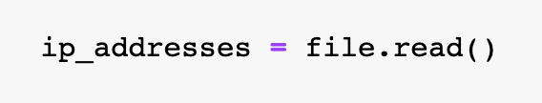

[I attached the .read() function to file because as stated above the information from the file we want was stored here we then save that data under a variable called ip_address]

## Convert the string into a list

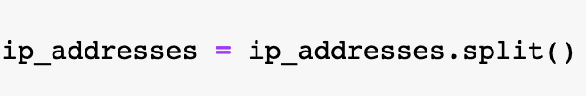

[we reassigned the value of ip_address to the split version of ip_address making it easier to read and work with ]

## Iterate through the remove list



[This code tells python that we want it to do something for all content in the remove_list. We havent specify what we want it to do yet ]

## Remove IP addresses that are on the remove list

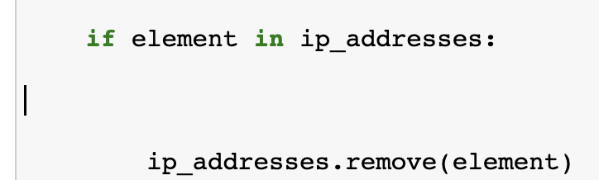

[This is a continuation of the last snippet of code. So in addition to the for statement header that we introduced previously i added the conditional statement that will look for ip addresses that are in the remove list and the approved ip addresses list and respectively removed the ip addresses that were no longer needed]

## Update the file with the revised list of IP addresses

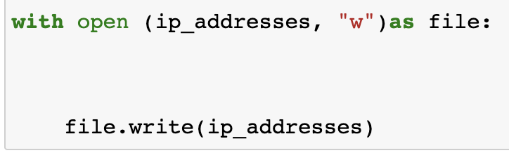

[The first line of code from this snippet tells python that we want to access the ip_address file with the intent to write to it.

The scond line of code passes in the updated list of ip addresses through the parentheses. And this updated list is to be written on the document listed as file. ]

## Summary

[This activity Provided me with a great opportunity to get hands on experience using python in a security aspect and it gave me alot of confidence being able to use python in ways that i would need to in my role as a security analyst.]